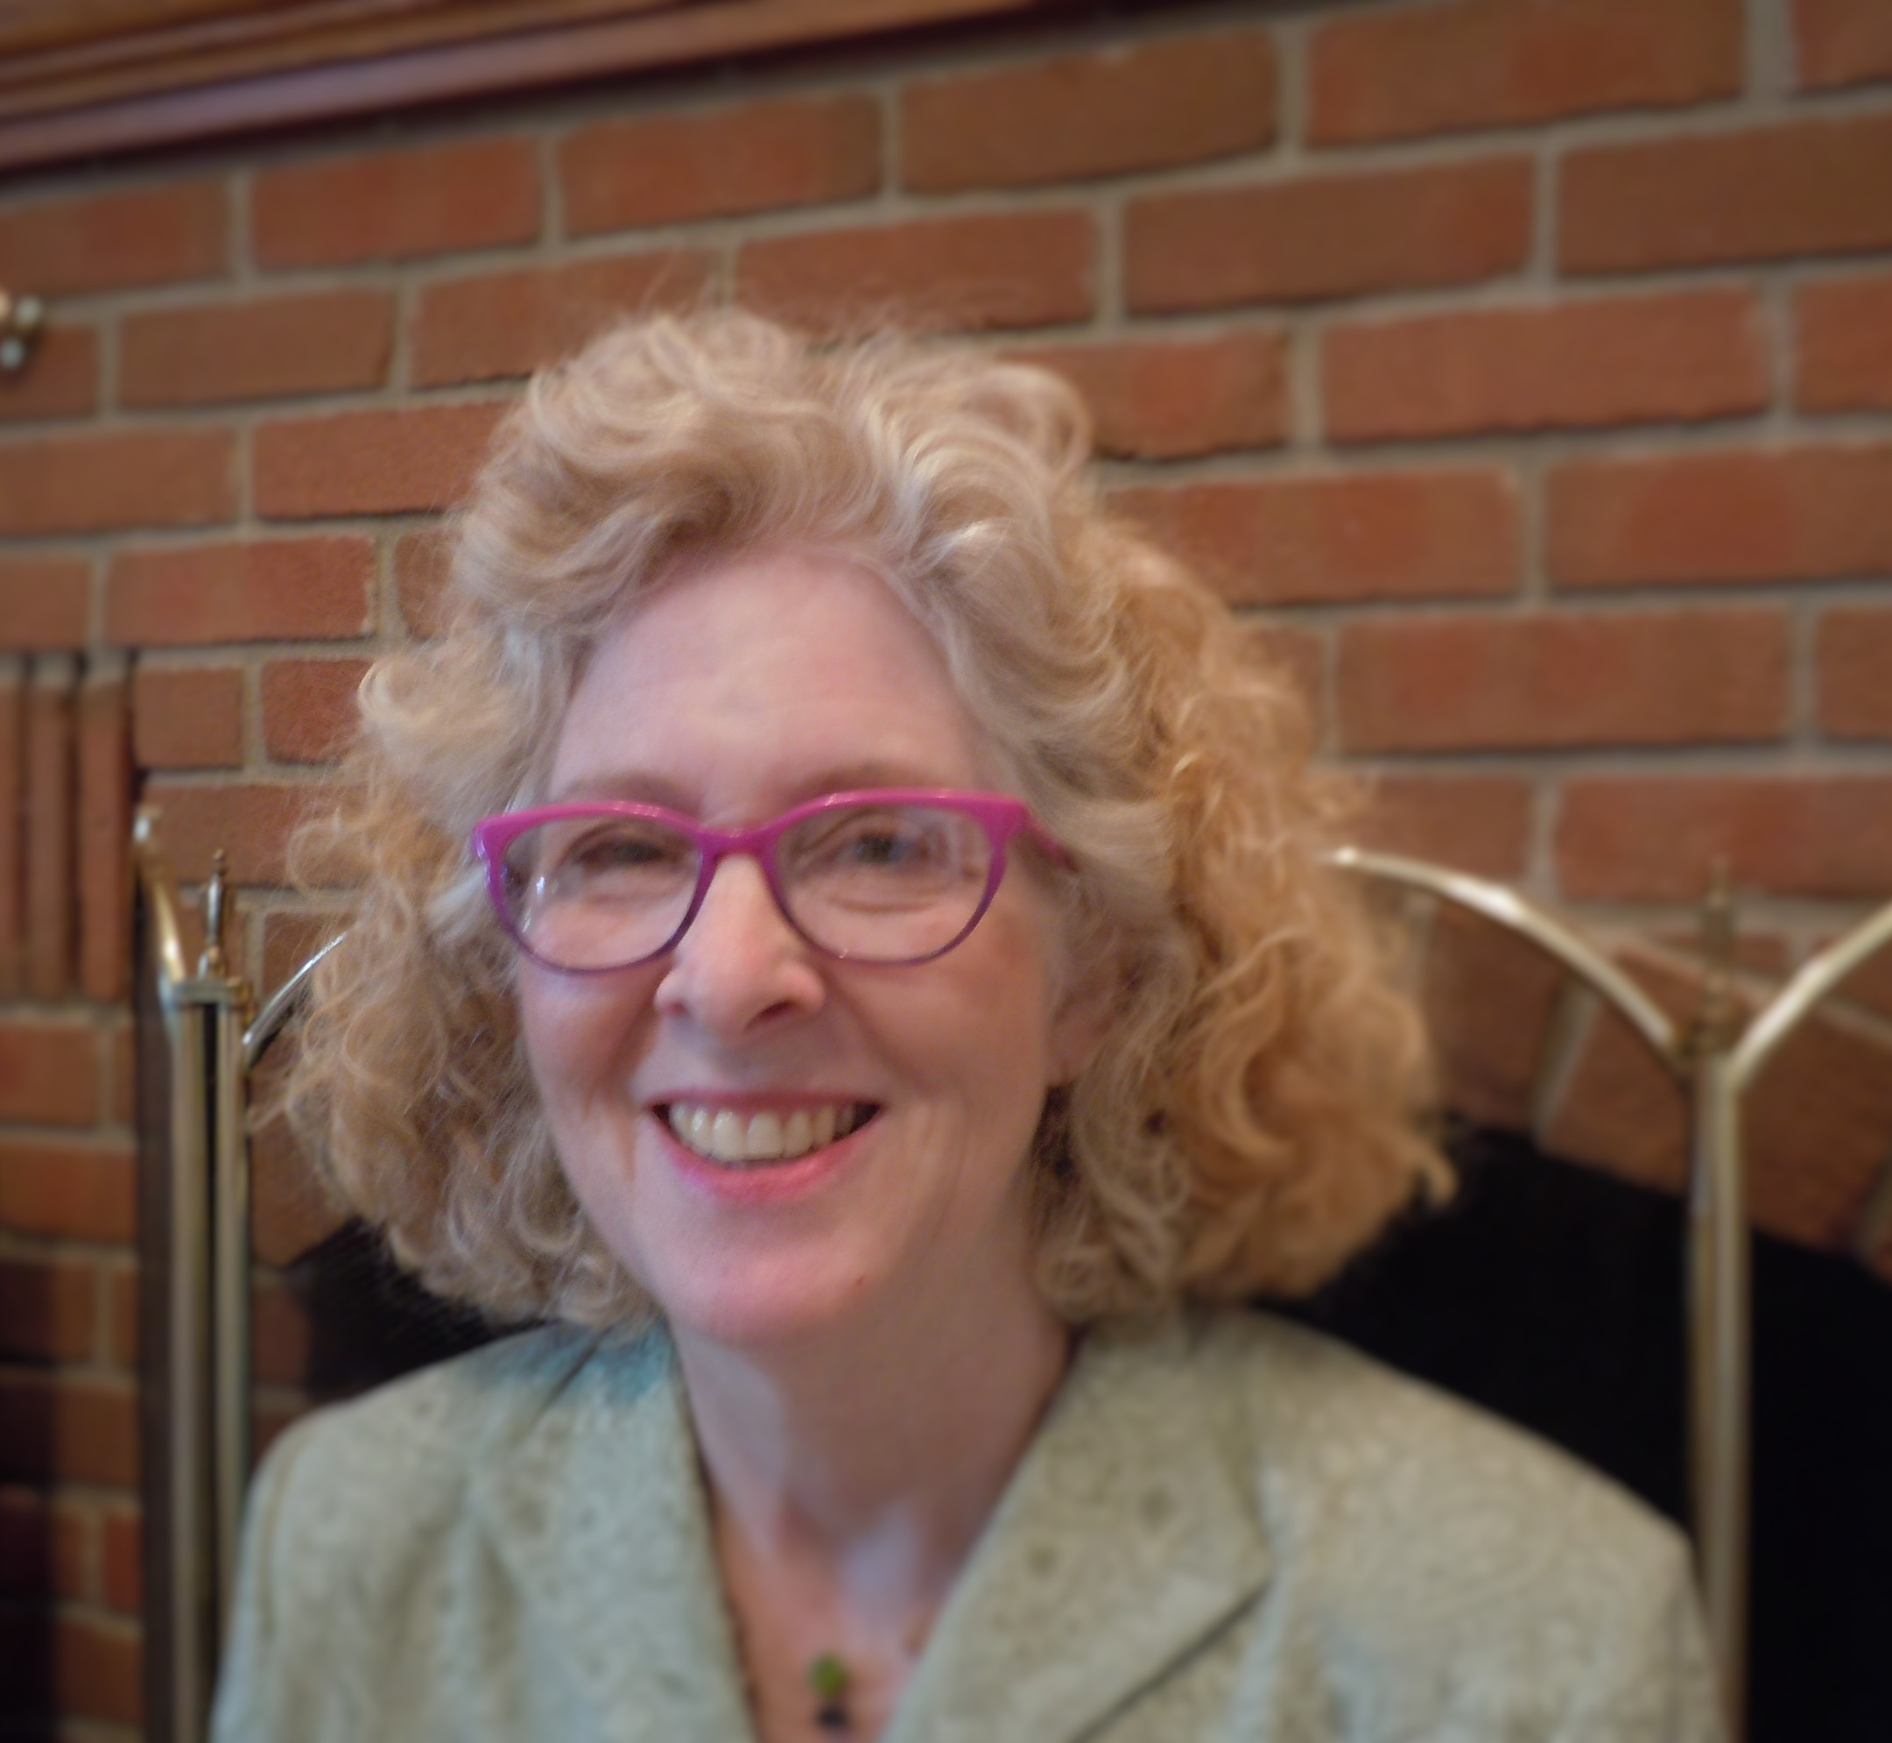

Reverend Beverly H. Seese

Minister at Unitarian Universalist Fellowship of Kokomo, Indiana
Beverly is a candidate for position #11 on the UUA Board of Trustees
Campaign email: bseeseteach1@gmail.com

The Rev. Beverly H. Seese was ordained in 2011, and has served as the part-time minister of the Unitarian Universalist Fellowship of Kokomo, IN, for the past 11 years, along with her active community ministry. She received her Master’s Degree from Meadville Lombard where her areas of specialization were Pastoral Counseling and Worship Arts. She took classes in Buddhism and titled her thesis “Choosing Non-Suffering”. She has been on the board of the UU Multiracial Unity Action Council for three years and co-chairs their Religious Professionals Task Force.
Rev. Beverly grew up in Modesto, CA, as a Church of the Brethren pacifist, and has taken training for non-violent social resistance. Among others, she participated in marches against nuclear proliferation in the Silicone Valley, CA;
with Forward On Climate in Washington, DC, in 2013; with the National Women’s March Rally in Indianapolis in 2017; and the Poor People’s Campaign’s march in Indianapolis, in 2021. Rev. Beverly served on the board, was a youth group advisor and directed the choir at her denomination's local church when she moved to Indiana thirty years ago. However, she grew impatient with the slow pace of instituting gay rights and diverse liberal religious thought, and changed her affiliation when she found a home with the Lafayette UU Church. There she served as Choir Director, Religious Education teacher, Ministerial Committee member and chair, and Chair of the Board, before deciding to go to seminary. Her California State University BA degree and teaching credentials are in Music and Consumer & Family Science, teaching in CA, OR, and IN. She has worked at an Indiana Community College branch as an academic advisor, and spent ten years as a counselor/academic advisor and ESL instructor at the Tippecanoe County Adult Education Program, working with immigrants and young people to gain their U.S. citizenship and High School Equivalency Diplomas. She volunteered three years as a “Big Sister” to a young teen mother. She is active in her small rural community serving on the boards of the Parks Department, Preservation Society, the Wabash and Erie Canal Park (where she does 1850s reenactment), and the Chapel Art Gallery. Beverly was an active Extension Homemaker and served as County-wide President for several years as well as directing the Extension Chorus for ten years. She loves music making, gardening, reading, quilting, and other creative arts. Beverly worked for a number of years in retail management and is now the owner/host of a historic B&B. Her husband, Carl Seese, recently retired from teaching Spanish and Social Studies. They enjoy visiting their daughter, in Denver, and son, close-by in Indiana.

I am running for this position because:
Unitarian Universalism should be allowed to maintain its historic integrity and proceed to its own future. A growing number of members are concerned that Unitarian Universalist principles and practices are being undermined.
I acknowledge the desire of many, especially younger and/or marginalized-identifying members, to take our religion in a radically different direction, perhaps to keep it from slowly dying of attrition as many members age out of full participation. I believe this is the wrong approach. I wholeheartedly support helping another branch of UUism to be formed that is more attractive to the aforementioned folks. (Maybe named 21st Century UUs; The traditionalists could be the UU Association of Churches – UUAC, again.) We do not need to be antagonistic toward one another. UUs have always been welcoming of other perspectives and opinions. Join me in calming the schism that has been growing between congregations’ members and various identity groups.
I am feeling called to this role in our Association by a large spectrum of our beloved community who are concerned about the erosion of our precious tradition.
I would be representing the heartland of our country and the growing sense of a lack of representation on this board, from all the different areas of the country. (Notice that all the members and nominated members of the board represent the East Coast, except one from GA and one from MN.)

